How to Setup and Run Selinium Test :

If already know how to run , please run the test case in slow speed. Fast speed might cause failure.

1. Download Mozilla Firefox Browser. (If already downloaded, skip this step)

Link : <https://www.mozilla.org/en-US/firefox/new/>

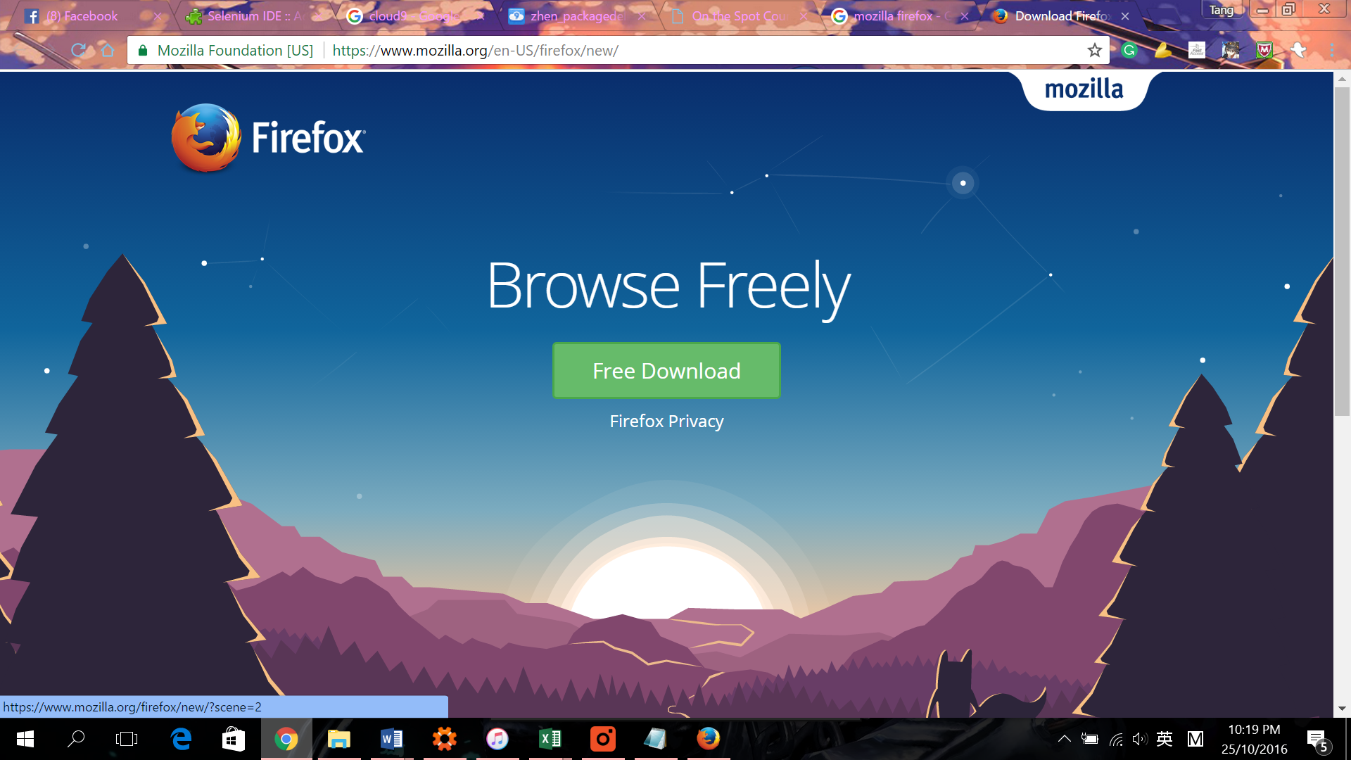

1. Open Browser, download plugin into the browser.

Link : https://addons.mozilla.org/en-US/firefox/addon/selenium-ide/

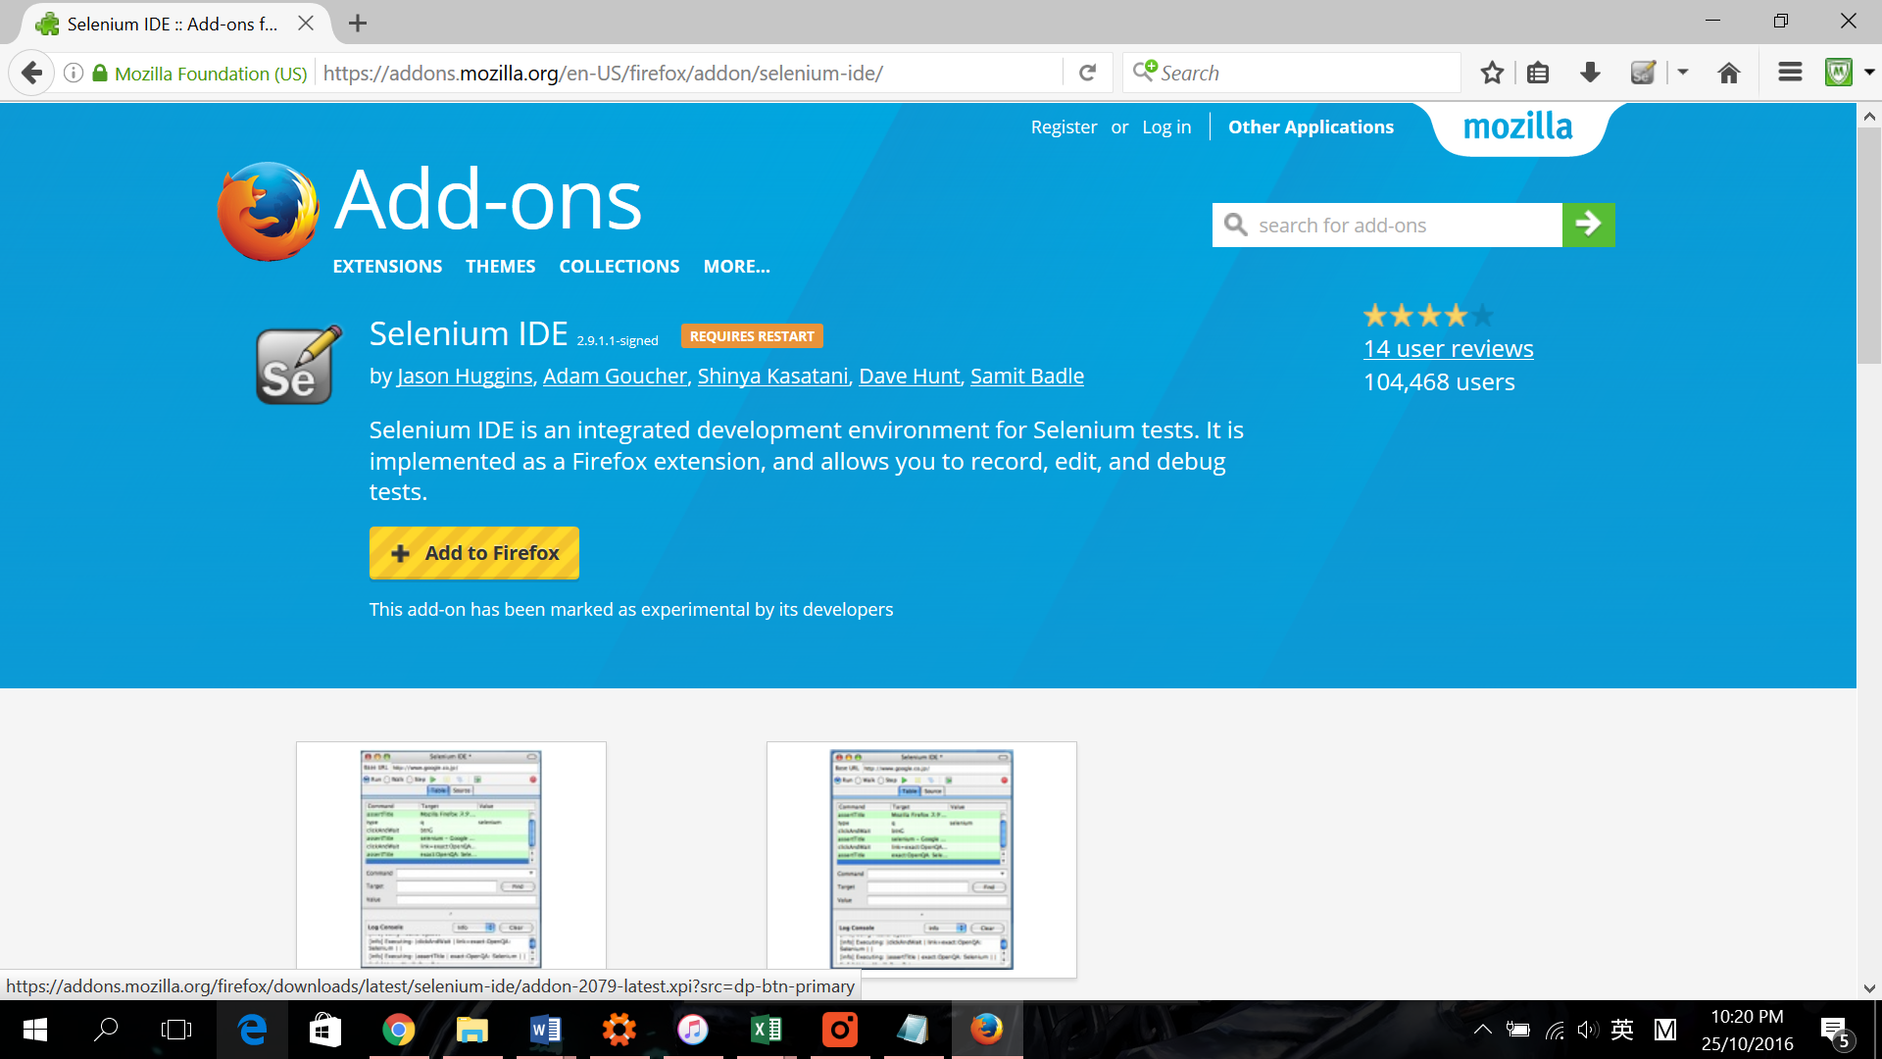

1. Locate Downloaded Plugin right here.

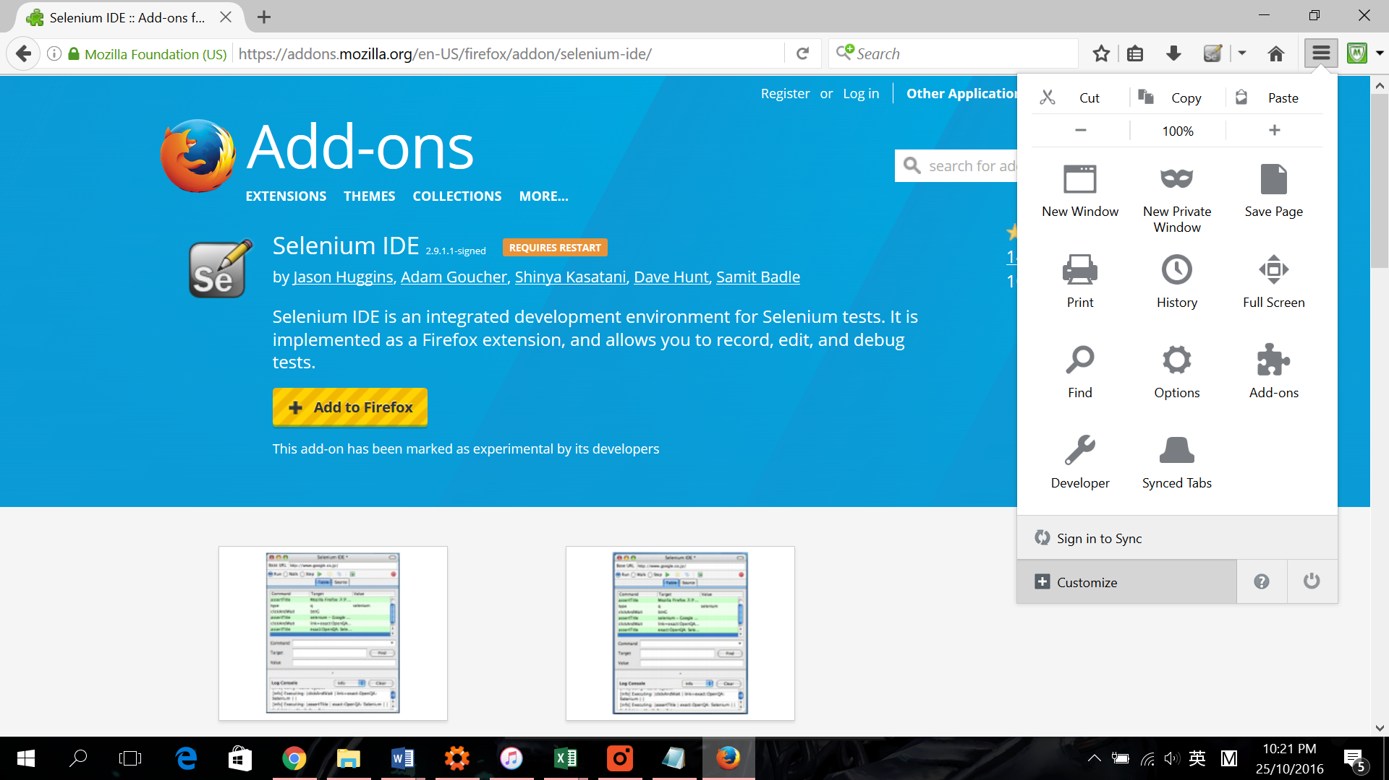

1. Drag the plugin to list

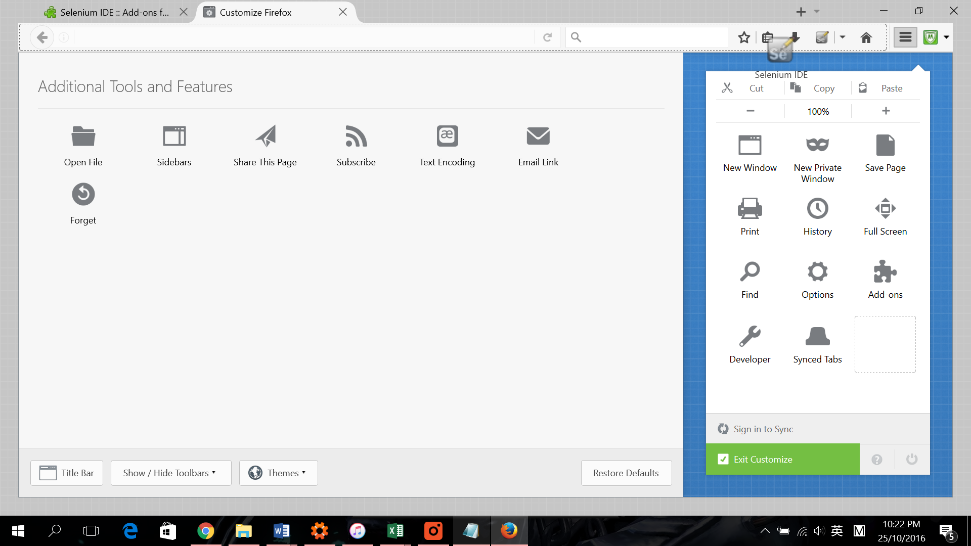

1. Open the plugin that located and top right corner

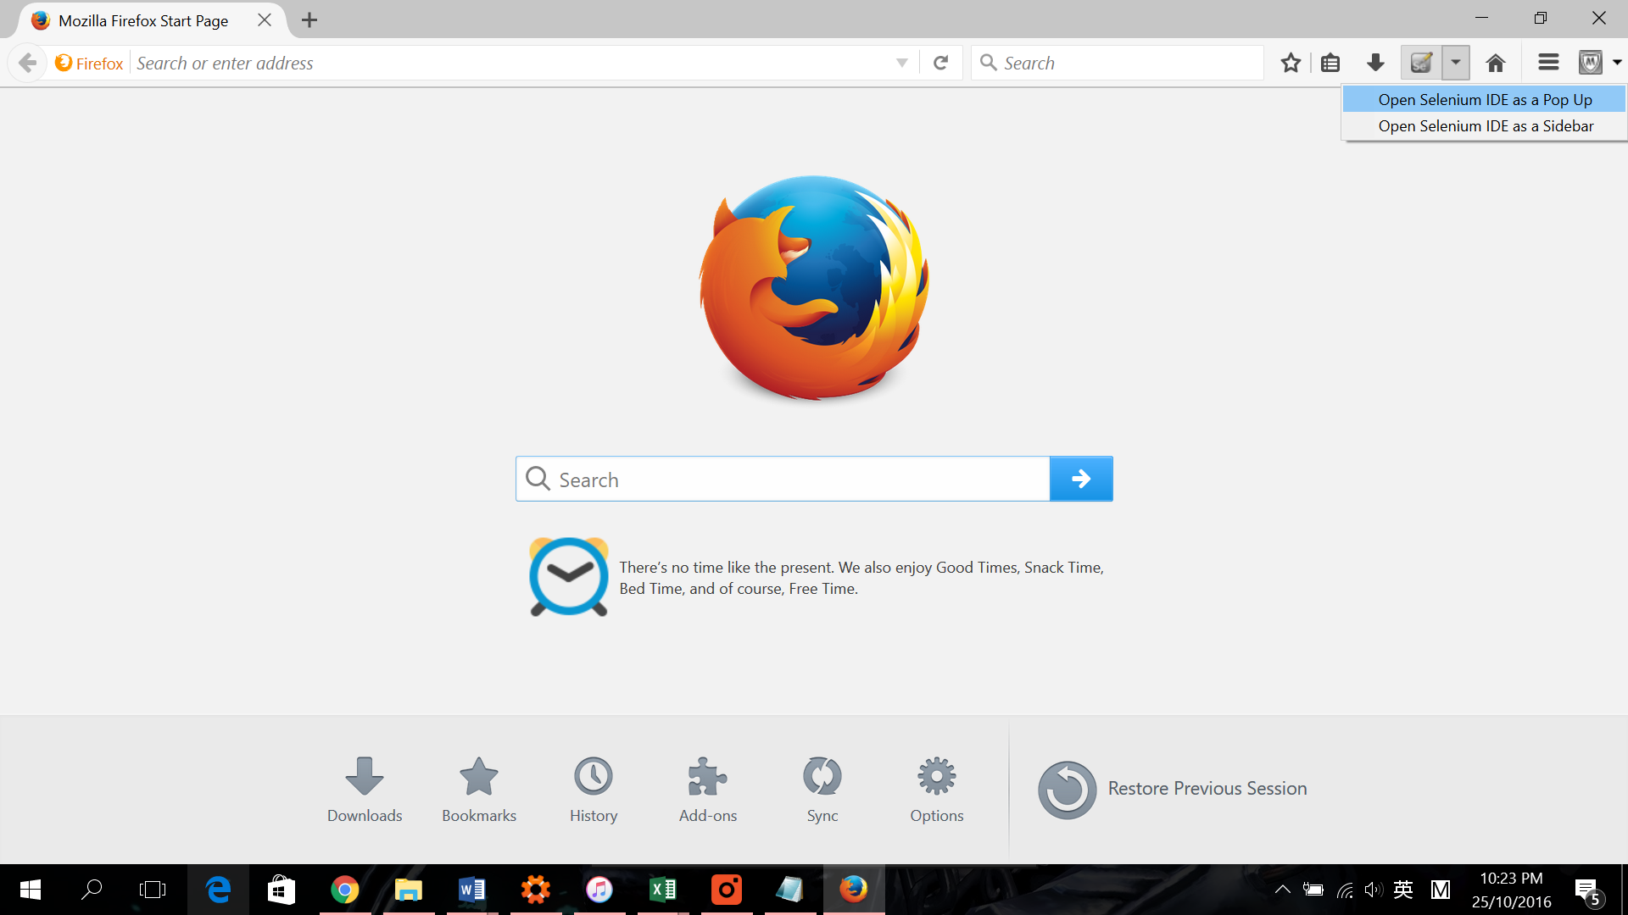

1. Select File -> Open …

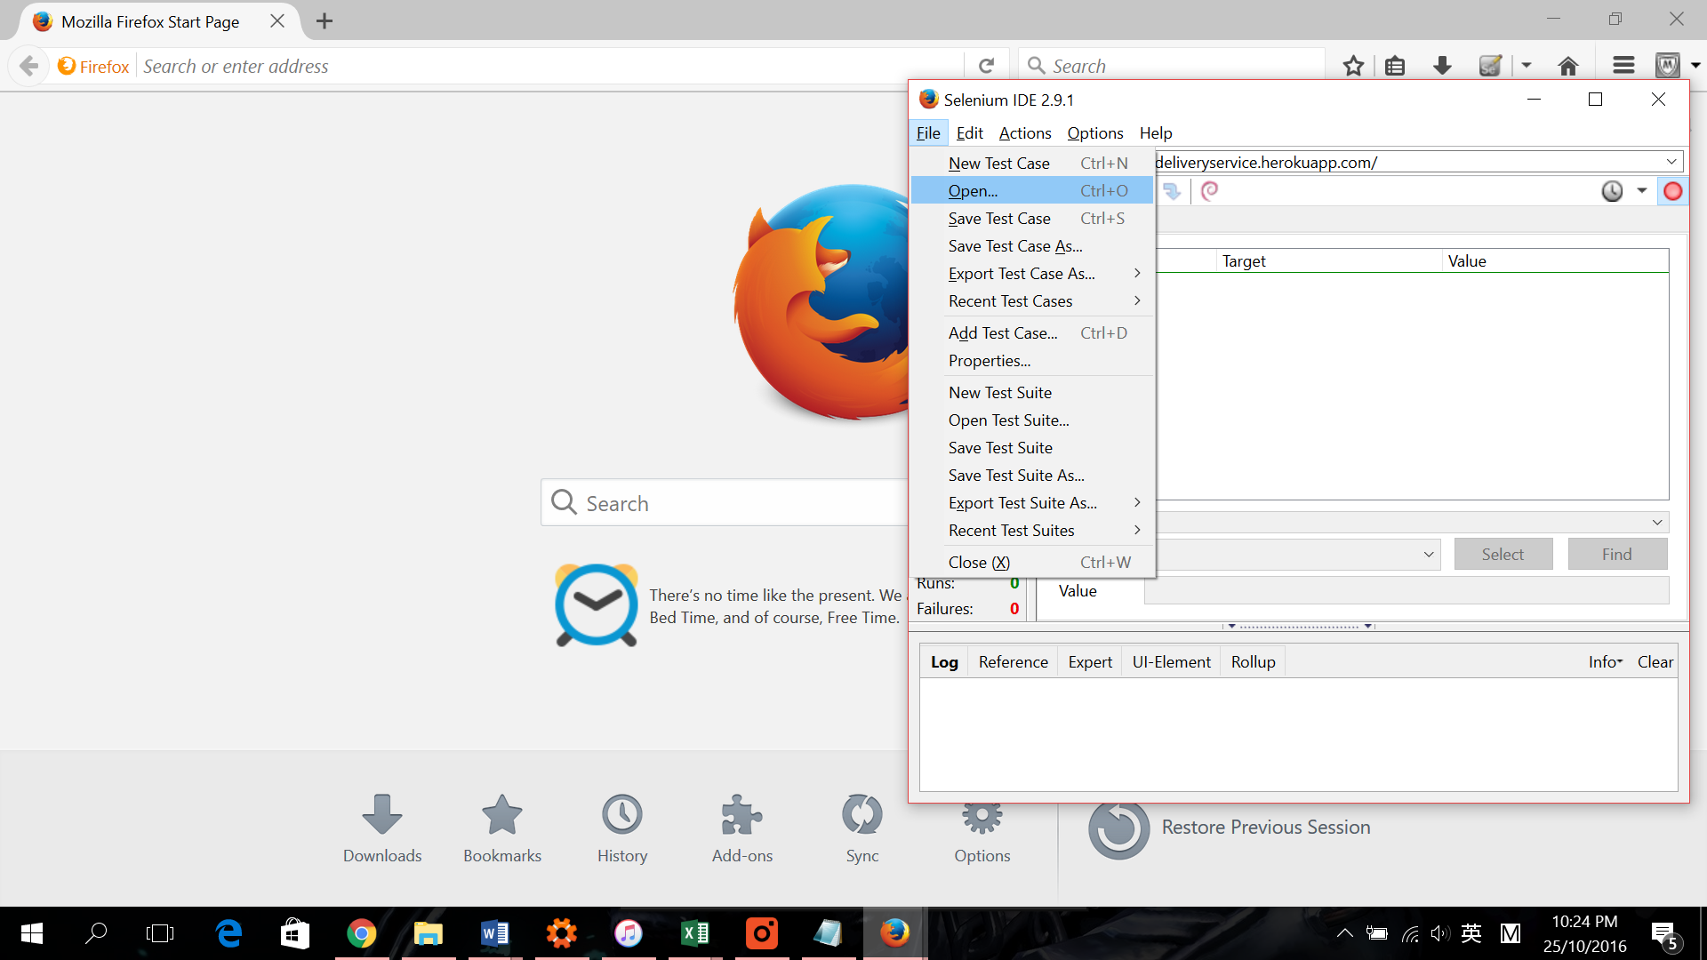

1. Locate Downloaded Test Case then open required test

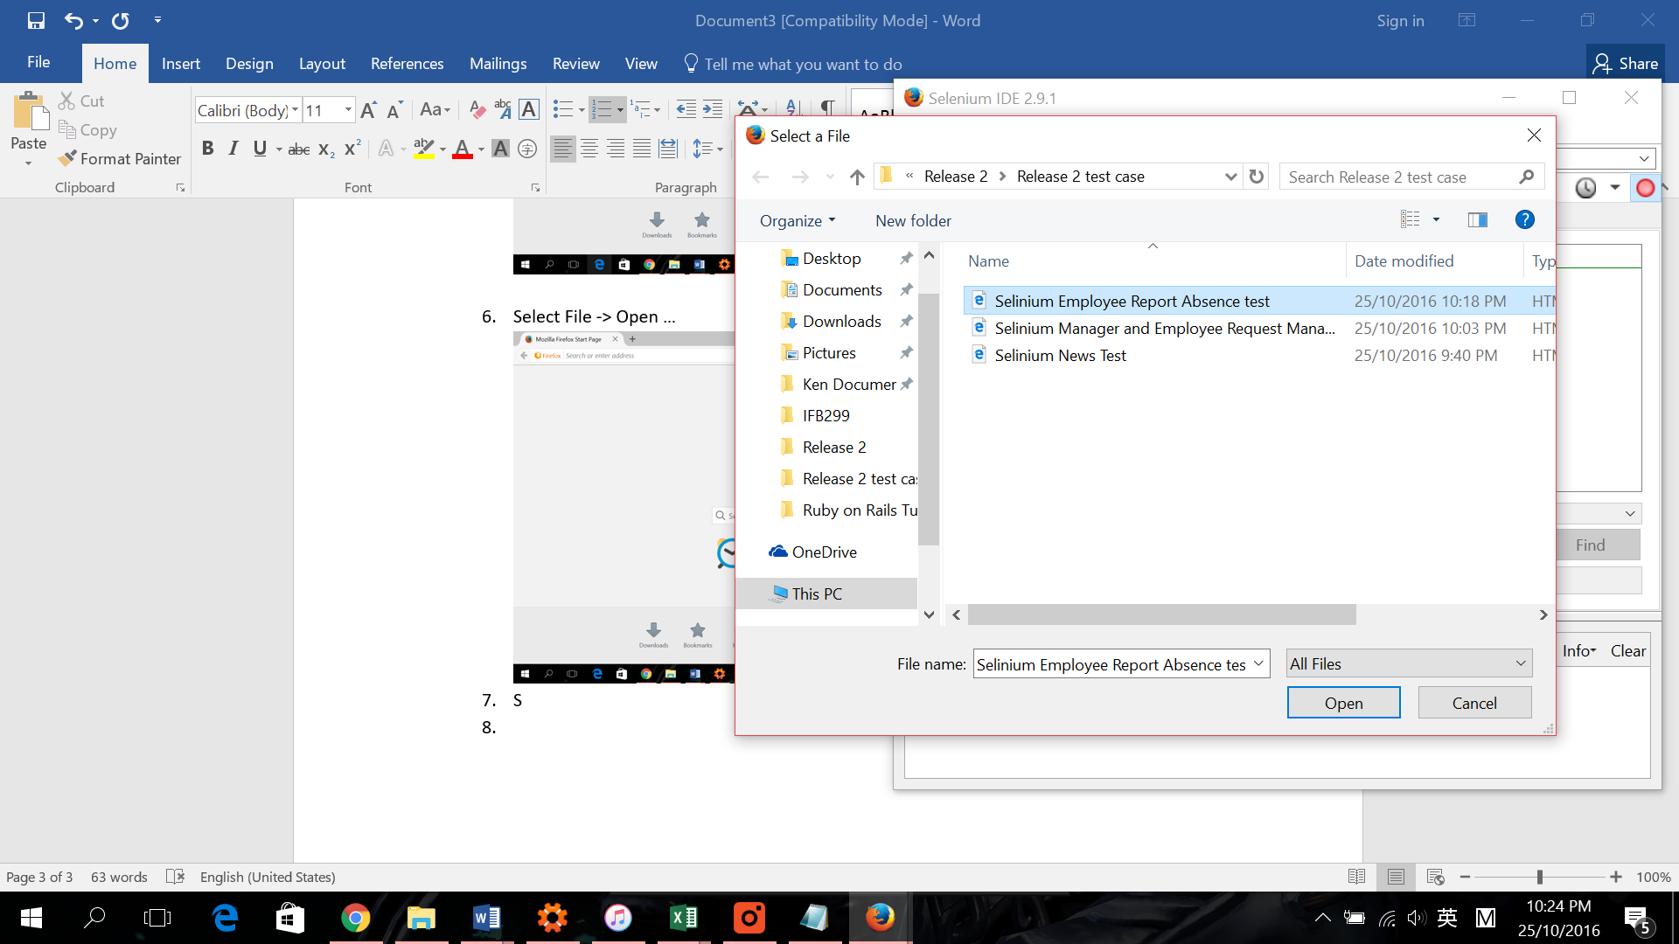

1. Play the test , Walla , all done.

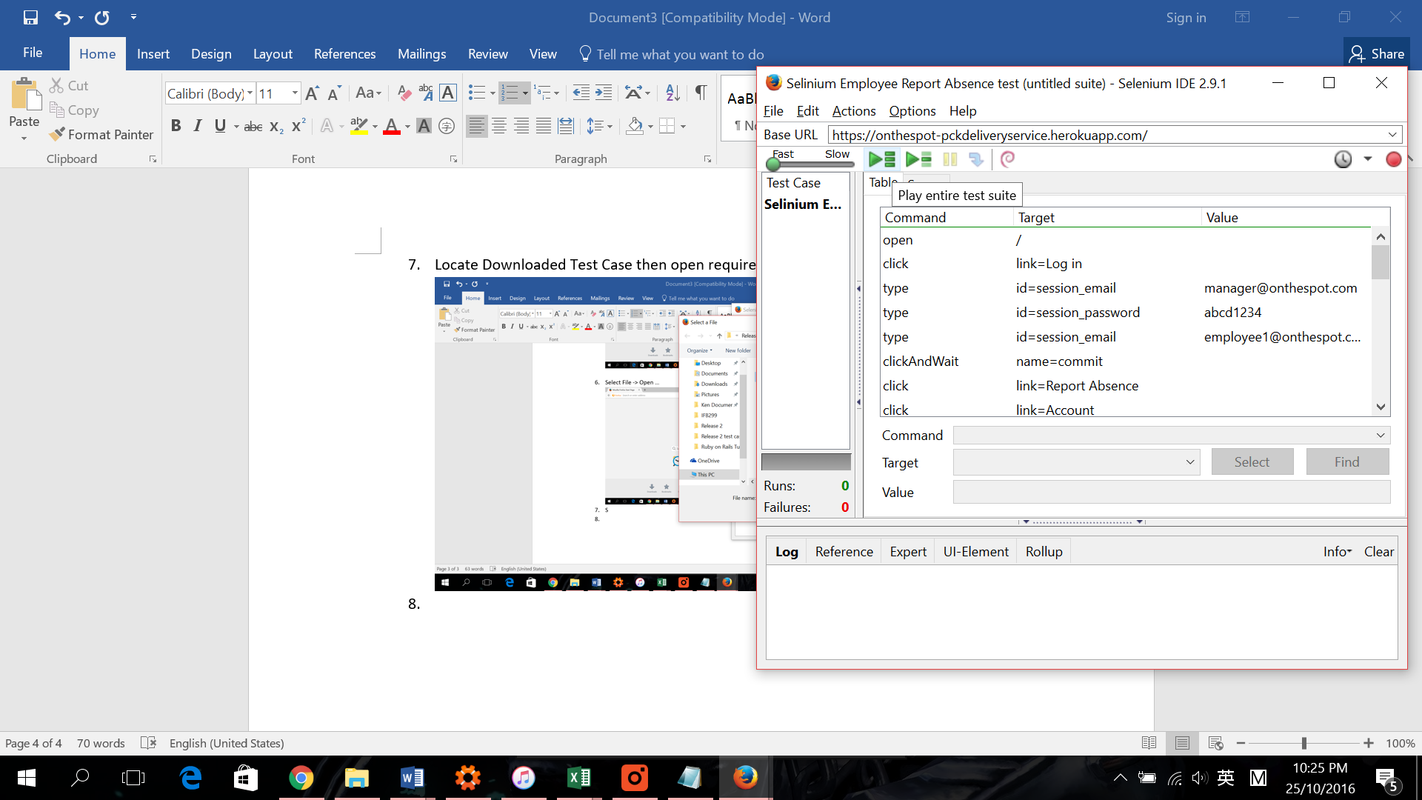

1. Please run the test in slow speed. Or might cause failure.

